Lab 2: Network Commands for Testing and Troubleshooting

Objective:
To familiarize ourselves with essential network commands used for testing and troubleshooting network connectivity issues.

Required Tools:
- A computer with command line interface (CLI) access
- Network connection (wired or wireless)

Network Commands:

Syntax and Usage of Common Network Commands:

ping
  - Syntax: ping [hostname or IP address]
  - Usage: Tests the reachability of a host on an IP network and measures the round-trip time for messages sent from the originating host to a destination computer.
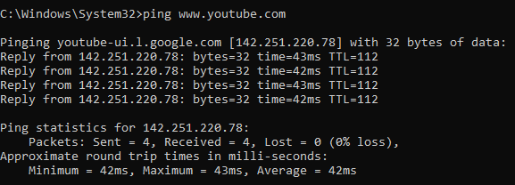

ipconfig (Windows) / ifconfig (Linux)
  - Syntax: ipconfig or ifconfig
  - Usage: Displays all current TCP/IP network configuration values and refreshes DHCP and DNS settings.
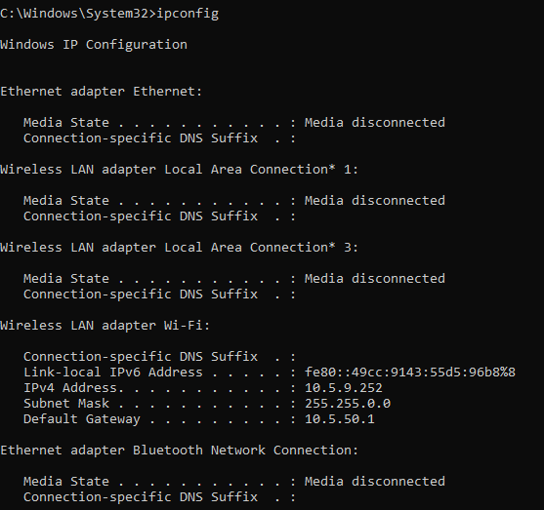

tracert (Windows) / traceroute (Linux)
  - Syntax: tracert [hostname or IP address] or traceroute [hostname or IP address]
  - Usage: Determines the route taken by packets to reach a specific host by listing all the intermediate routers.

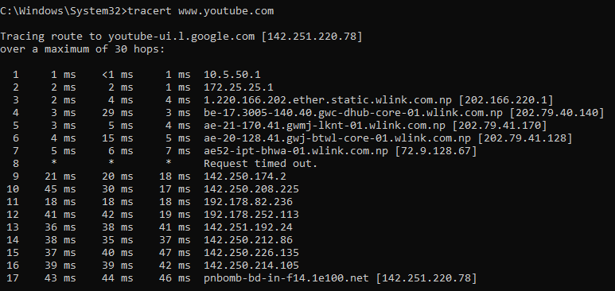

netstat
  - Syntax: netstat -a or netstat -n
  - Usage: Displays active TCP connections, ports on which the computer is listening, Ethernet statistics, and more.
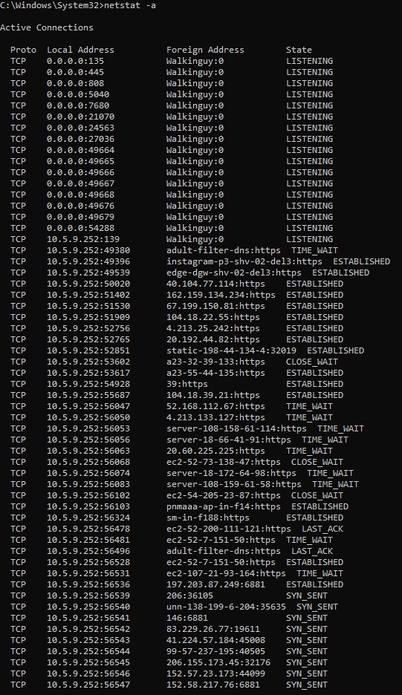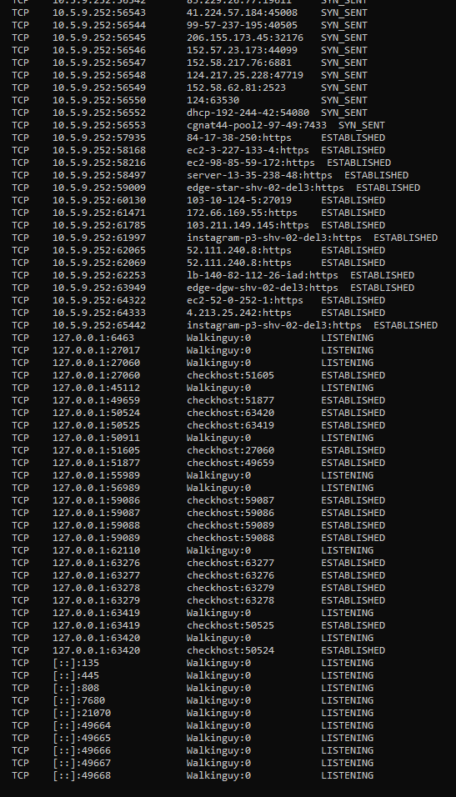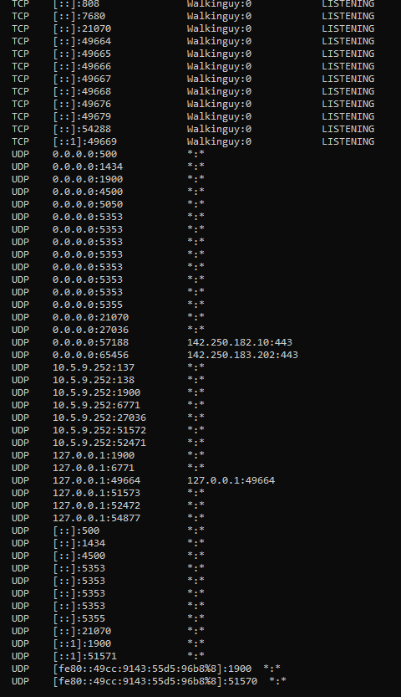

nslookup
  - Syntax: nslookup [hostname]
  - Usage: Queries the Domain Name System (DNS) to obtain domain name or IP address mapping information.
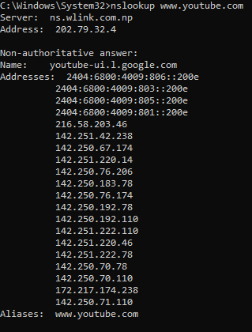

arp
  - Syntax: arp -a
  - Usage: Displays and modifies the IP-to-Physical (MAC) address translation table used by the Address Resolution Protocol (ARP).
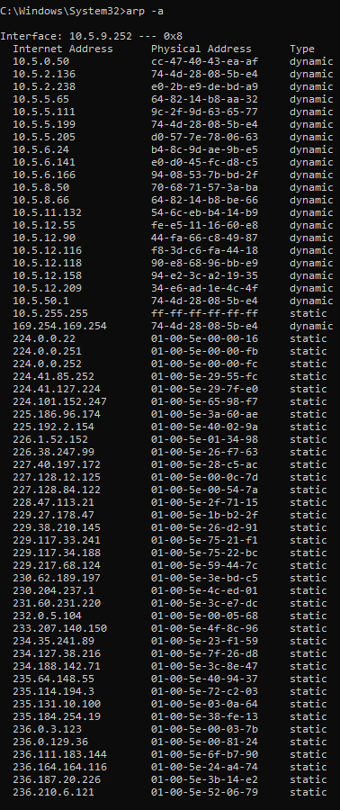

telnet
  - Syntax: telnet [hostname or IP address] [port]
  - Usage: Connects to a remote host using the Telnet protocol, useful for testing connectivity to specific ports.
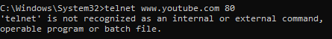
//No output due to installation issue.

netsh wlan (Windows)
  - Syntax: netsh wlan show profiles or netsh wlan connect name=[profile name]
  - Usage: Manages wireless network profiles and connections on Windows systems.
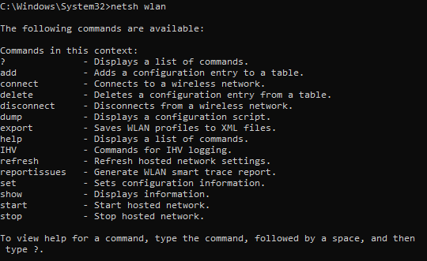

pathping
  - Syntax: pathping [hostname or IP address]
  - Usage: Combines the functionality of ping and tracert to provide information about network latency and packet loss at each hop.
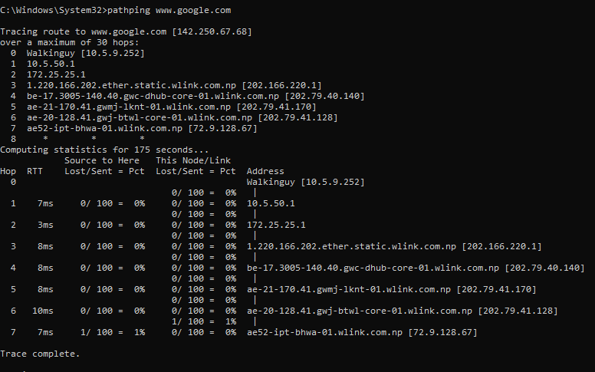

route print
  - Syntax: route print
  - Usage: Displays the current IP routing table on the local machine.
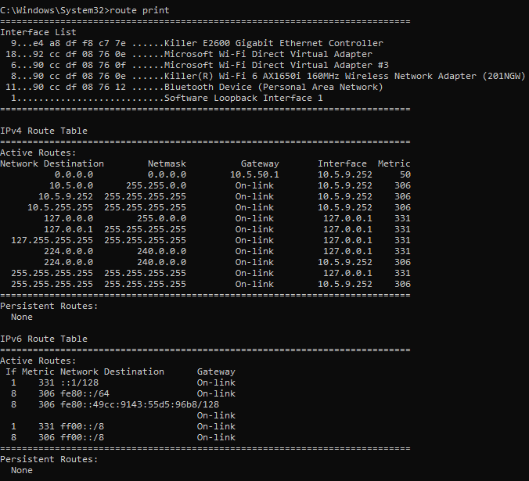

getmac
  - Syntax: getmac
  - Usage: Displays the MAC addresses for network adapters on the local machine.
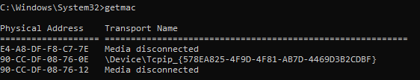

nbtstat
  - Syntax: nbtstat -a [hostname]
  - Usage: Displays NetBIOS over TCP/IP statistics, including the NetBIOS name table of a remote computer.
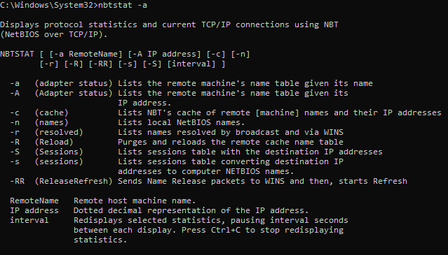

whois
  - Syntax: whois [domain name]
  - Usage: Retrieves registration information about a domain name from the WHOIS database.

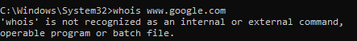

Discussion
In this lab, straight-through and crossover Ethernet cables were prepared using RJ45 connectors according to standard wiring schemes. Proper crimping and correct color arrangement ensured accurate pin connections. Cable testing confirmed continuity for all wires and correct pair crossing in the crossover cable, indicating that there were no wiring faults and that the cables functioned as expected.

Conclusion
The experiment successfully demonstrated the construction and testing of Ethernet cables. Both cable types were correctly terminated and verified using a cable tester. This lab improved practical understanding of Ethernet wiring standards, cable preparation, and the importance of testing for reliable network connections.

